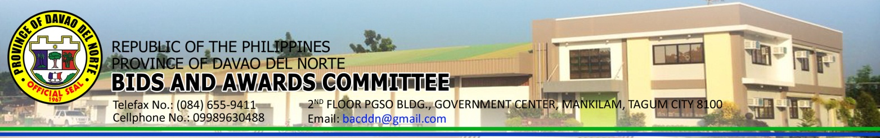
INVITATION TO BID
AFTER TWO FAILED BIDDING
The Provincial Government of Davao del Norte, through its Bids and Awards Committee (BAC) invites PhilGEPS registered suppliers to submit bid proposals in a duly sealed envelope together with the bid security for the hereunder project under negotiated procurement.
Bid No. | PR No. | Classification | Name of Project/s | ABC
B20160079 | 1603-1479 | Goods | Procurement of 1 unit Motor Vehicle with complete accessories for DILG/PPOC operation | P | 1,500,000.00
B20160080 | 1603-1467 | Goods | Procurement of 1 unit Pick up Type Vehicle for PTO use | P | 1,135,000.00
B20160083 | 1601-0976 | Civil Works | Procurement of 1 unit Contract Package – Maintenance of Various Provincial Roads & Bridges District 2, (MBC) | P | 2,678,003.90
B20160084 | 1602-1106 | Civil Works | Procurement of 1 unit Contract of Various Projects within 1st Engineering District | P | 1,891,101.85
B20160085 | 1601-1429 | Civil Works | Procurement of 1 Contract Package for Various Projects around DDN | P | 2,410,892.52

The Preliminary Examination of Bids shall use non-discretionary “pass/fail” criterion. Post-qualification of the lowest calculated bid shall be conducted.

All particulars relative to Screening of Bid Security, Performance Security, Evaluation of Bids, Post-Qualification and Award of Contract shall be governed by the pertinent provisions of R.A. 9184 and its Implementing Rules and Regulation (IRR).

The complete schedule of the activities is listed, as follows:

ACTIVITY | DATE/S
1. Issuance of Invitation to Bid | May 24, 2016 – May 30, 2016
2. Opening of Bids | May 31, 2016, 10:00 A.M.  2nd Floor PGSO Bldg., PGSO Conference Room

The Provincial government of Davao del Norte assumes no responsibility whatsoever to compensate or indemnify bidders for any expenses incurred in the preparation of the Bid.

Approved by:

ATTY. EDD MARK O. WAKAN
Provincial Legal Officer / BAC Chairman
Province of Davao del Norte
Mankilam, Tagum City
Tel.No. (084) 216-6904
Fax No. (084) 655-9411
Website: www.davaodelnorte.gov.ph
BAC-BID-NP-05-16-003

